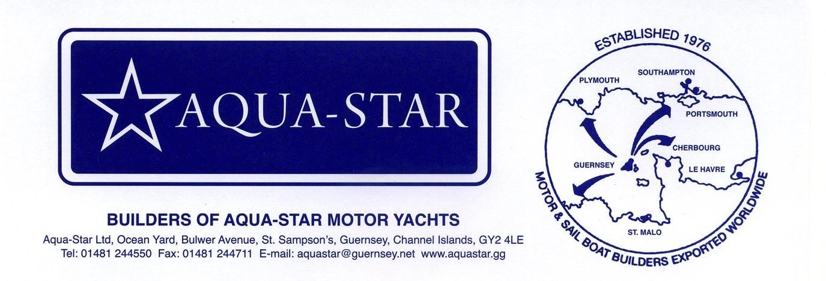

Ref 973

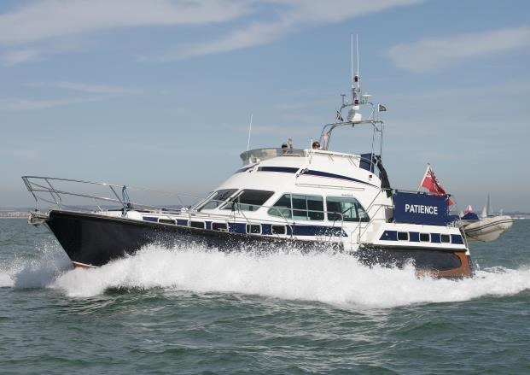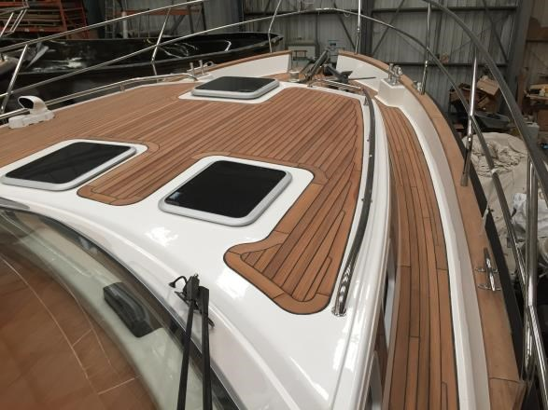

Aquastar 45' Aft Cabin
Built 2001 But regularly updated and refitted. Latest refit 2015

Standard specification with a dinette layout.
Blue hull, white deck with blue stripe, compounded and polished 2015

Mechanical & electrical
- Twin Caterpillar 3126 426HP handed engines
- 6kw generator
- Optional increased 600 gallon fuel capacity
- Plug points 240v & shore supply
- 4 domestic batteries (new 2012) and 2 starter batteries
- Pro charge ultra battery charger (new 2012)
- Bow thruster
- Trim tabs
- Prop shaft cutters
- Electric anchor winch
- Hand and electric bilge pumps
- Engine room and generator fire extinguishers (new 2012)
- Dual steering position
- Holding tank with deck discharge
- Exhaust alarms
- Fuel King to engines and generator
- PSS shaft seals (new 2014)
- New P Bracket cutlass bearings 12015

External
- Teak decks throughout (new 2015)
- Epoxy resin bottom from new prior to anti-fouling
- 20kg Bruce anchor on bow roller
- 15kg Danforth kedge anchor in chocks on foredeck
- Hot & cold water deck shower
- Fresh water screen washers
- Whittle stainless steel davits
- Avon rib with centre consol steering and 15hp Yamaha outboard
- Windscreen cover
- Aft door cover & frame, flybridge and stern seat cover
- Hatch to chain locker
- Hydraulic mast lowering system
- 6 man life raft and frame with hydrostatic release
- Teak hull badging varnished like new 2015

Navigational
- Lower Helm o Raymarine C120W colour radar/plotter, 4kw 48” HD open array digital radar & Navionics gold software (all new 2011)
o Raymarine ST60+Tridata display (new 2012) o Raymarine ST6002 autopilot (new 2012)
- Upper Helm o Raymarine C120W colour radar/plotter (new 2011) o Raymarine ST60+ repeater (new 2012) o Raymarine ST6002 autopilot repeater (new 2012)
- Raymarine AIS 650 Class B tranceiver (new 2011)
- Icom M505 DSC VHF plus Icom HM162 Command mic to upper helm (new 2012)
- ICS Nav 4 printing Navtex
- Auto fog horn to flybridge

Internal
- LED lighting throughout (new 2014)
- Oceanair venetian blinds to saloon (new 2014)
- Hot air heating to each cabin
- Air conditioning to Saloon
- Wifi hub with 3G/4G router and long range antenna (new 2014)
- Radio CD player with 2 speakers in cabin and 2 to aft deck (new 2012)
- TV aerial
- Isotherm fridges to galley (new 2012) and flybridge (new 2013)
- Freezer under Dinette
- Galley extractor fan
- Gas detector (new 2012)
- Vacuum toilets
- Safe

ASKING PRICE £195,000.00 This years Star buy VAT Cleared LYING South Coast

In this case we are acting as Brokers only. Vendor is not selling in the course of business. Whilst every care has been taken in their preparation, the correctness of these particulars are not guaranteed. The particulars are intended only as a guide and they do not constitute a term of any contract. A prospective buyer is strongly advised to check the particulars and whenever appropriate, at his own expense to employ a qualified marine surveyor to carry out a survey and/or have an engine trial conducted.

E&OE

